5-4-2019

**david gutierrez alvarez**

**Estructura de datos I**



##### **LA PILA Y LA COLA, IMPLEMENTACIÓN DINÁMICA**

|  |
| --- |
| **RESUMEN PERSONAL Y FORMA DE ABORDAR EL PROBLEMA** |

Como ya se sabe, la implementación de herencia se utilizo para resolver este ejercicio, por dificultades de tiempo no pude implementar algo que fuera eficiente, pero lo hice funcional

|  |
| --- |
| **Main.cpp** |
| **#include <iostream>**  **#include "menu.h"**  ***using* *namespace* std;**  **int main() {**  **Menu menu;**  **cout << "Fin!" << endl;**  ***return* 0;**  **}** |

|  |
| --- |
| **Menu.h** |
| **#ifndef MENU_H**  **#define MENU_H**  **#include "stack.h"**  **#include "stack.cpp"**  **#include "queue.h"**  **#include "queue.cpp"**  **#include <iostream>**  ***class* Menu {**  ***public*:**  **Menu();**  **void converter(*const* std::string &);**  **bool operatorValid(*const* char &);**  **int precedencia(*const* char &);**  **};**  **#endif *//* *MENU_H*** |

|  |
| --- |
| **Menu.cpp** |
| **#include "menu.h"**  **#include <string.h>**  ***using* *namespace* std;**  **Menu::Menu() {**  **string continue_, operation;**  ***do*{**  **cout << "\t\t\t\t.:MENU:." << endl << endl**  **<< "Introduce una operacion infija: ";**  **getline(*cin*, *operation*);**  **converter(operation);*/*convierte* *operacion* *infija* *a* *posfija*/***  **cout << endl << "Desea introducir otra operacion: S/N" << endl;**  **getline(*cin*, *continue_*);**  **cout << endl << endl;**  **} *while*(continue_ == "S" *or* continue_ == "s");**  **}**  **void Menu::converter(*const* string &infija) {**  ***//* *int* *count* *=* *0;* *///con* *esto* *vere* *el* *inicio* *y* *fin* *de* *los* *parentesis***  **Stack<char> pila;**  **Queue<char> cola;**  ***for* (size_t i = 0; i < infija.size(); i++) {**  **cola.enqueue(infija.c_str()[i]);*/*mete* *todos* *los* *datos* *en* *la* *cola*/***  **}**  ***while* (!cola.empty()) {**  ***/*mentras* *haya* *algun* *dato*/***  ***if*(operatorValid(cola.getFront())) {**  ***/*si* *es* *un* *operador*/***  ***if*(precedencia(cola.getFront()) == 4){**  ***/*insertar* *en* *pila*/***  **pila.push(cola.getFront());**  **}**  ***if*(precedencia(cola.getFront()) == 5) {**  ***while* (!pila.isEmpty() *and* pila.getTop() != '(') {**  ***/*extraer* *elemento* *de* *la* *pila* *y* *mostrarlo*/***  **cout << pila.pop();**  **}**  ***if*(pila.getTop() == '(') {**  ***/*sacarlo* *de* *la* *pila* *pero* *sin* *mostrarlo*/***  **pila.pop();**  **}**  **}**  ***if*(precedencia(cola.getFront()) < 4) {**  ***/*si* *es* *un* *operador*/***  ***while*(!pila.isEmpty() *and* precedencia(pila.getTop()) >= precedencia(cola.getFront()) *and* precedencia(pila.getTop() != 4)) {**  ***/*mientras* *que* *la* *pila* *no* *este* *vacia* *y* *su* *tope* *tenga* *una* *precedencia* *mayor*/***  ***/*sacar* *el* *untilo* *elemento* *y* *mostrarlo*/***  **cout << pila.pop();**  **}**  **pila.push(cola.getFront());**  **}**  **} *else* {**  **cout << cola.getFront();**  **}**  **cola.dequeue();**  **}**  ***while* (!pila.isEmpty()) {**  **cout << pila.pop();**  **}**  **}**  **bool Menu::operatorValid(*const* char &data) {**  **char operators[8] = "+-*/^()";**  ***for* (size_t i = 0; i < 7; i++) {**  ***if*(operators[i] == data) {**  ***return* *true*;**  **}**  **}**  ***return* *false*;**  **}**  **int Menu::precedencia(*const* char &operator_) {**  ***switch* (operator_) {**  ***case* '+':**  ***case* '-': *return* 1;**  ***case* '*':**  ***case* '/': *return* 2;**  ***case* '^': *return* 3;**  ***case* '(': *return* 4;**  ***case* ')': *return* 5;**  **}**  ***return* 0;**  **}** |

|  |
| --- |
| **List.h** |
| **#ifndef LIST_H**  **#define LIST_H**  **#include <iostream>**  ***template*<*typename* Type>**  ***class* List {**  ***public*:**  ***class* Exception : *public* std::exception {**  ***private*:**  **std::string msg;**  ***public*:**  ***explicit* Exception(*const* char* message) : msg(message) { }**  ***explicit* Exception(*const* std::string& message) : msg(message) { }**  ***virtual* ~*Exception*() *throw* () { }**  ***virtual* *const* char* *what*() *const* *throw* () { *return* msg.c_str(); }**  **};**  ***class* Node {**  ***private*:**  **Type data;**  **Node *next;**  ***public*:**  **Node();**  **Node(*const* Type &);**  **Type &getData() ;**  **Node *getNext() *const*;**  **void setData(*const* Type &);**  **void setNext(Node *);**  **};**  ***private*:**  **Node *anchor;**  **bool validPos(Node*) *const*;**  **void copyAll(*const* List &);**  ***public*:**  **List();**  **List(*const* List &);**  **~List();**  **bool empty() *const*;**  **void insert(Node *, *const* Type &);**  **void erase(Node *);**  **Node *getFirst() *const*;**  **Node *getLast() *const*;**  **Node *getPrev(Node *) *const*;**  **Node *getNext(Node *) *const*;**  **Node *find(*const* Type &) *const*;**  **Type &retrieve(Node *);**  **std::string toString() *const*;**  **void deleteAll();**  **List &*operator* = (*const* List &);**  **};**  ***///* *Implementacion***  ***///* *Node* *///***  ***template*<*typename* Type>**  **List<Type>::Node::Node() : next(*nullptr*) { }**  ***template*<*typename* Type>**  **List<Type>::Node::Node(*const* Type &e) : data(e), next(*nullptr*) { }**  ***template*<*typename* Type>**  **Type &List<Type>::Node::getData() {**  ***return* data;**  **}**  ***template*<*typename* Type>**  ***typename* List<Type>::Node* List<Type>::Node::getNext() *const* {**  ***return* next;**  **}**  ***template*<*typename* Type>**  **void List<Type>::Node::setData(*const* Type &e) {**  **data = e;**  **}**  ***template*<*typename* Type>**  **void List<Type>::Node::setNext(List<Type>::Node *p) {**  **next = p;**  **}**  ***///* *List* *///***  ***template*<*typename* Type>**  **bool List<Type>::validPos(List<Type>::Node *p) *const* {**  ***if*(empty()) {**  ***return* *false*;**  **}**  **Node * aux(anchor);**  ***do* {**  ***if*(aux == p) {**  ***return* *true*;**  **}**  **aux = aux->getNext();**  **}*while* (aux != anchor);**  ***return* *false*;**  **}**  ***template*<*typename* Type>**  **void List<Type>::copyAll(*const* List &l) {**  **Node *aux(l.anchor);**  **Node *last(*nullptr*);**  **Node *newNode;**  ***do*{**  **newNode = *new* Node(aux->getData());**  ***if*(newNode == *nullptr*) {**  ***throw* List<Type>::Exception("Memoria no disponible, coplyAll");**  **}**  ***if*(last == *nullptr*) {**  **anchor = newNode;**  **} *else* {**  **last->setNext(newNode);**  **}**  **last = newNode;**  **aux = aux->getNext();**  **} *while* (aux != l.anchor);**  **last->setNext(anchor);**  **}**  ***template*<*typename* Type>**  **List<Type>::List() : anchor(*nullptr*) { }**  ***template*<*typename* Type>**  **List<Type>::List(*const* List &l) {**  **copyAll(l);**  **}**  ***template*<*typename* Type>**  **List<Type>::~List() {**  **deleteAll();**  **}**  ***template*<*typename* Type>**  **List<Type> &List<Type>::*operator* = (*const* List<Type> &l) {**  **deleteAll();**  **copyAll(l);**  ***return* \**this*;**  **}**  ***template*<*typename* Type>**  **bool List<Type>::empty() *const* {**  ***return* anchor == *nullptr*;**  **}**  ***template*<*typename* Type>**  **void List<Type>::insert(List<Type>::Node *p, *const* Type &e) {**  ***if*(p != *nullptr* *and* !validPos(p)) {**  ***throw* Exception("posicion invalida, insert");**  **}**  **Node *aux(*new* Node(e));**  ***if*(aux == *nullptr*) {**  ***throw* Exception("memoria no disponible, insert");**  **}**  ***if*(p == *nullptr*) { *//* *inserta* *al* *principio***  ***if*(empty()) { *//* *insertar* *el* *primer* *elemento***  **aux->setNext(aux);**  **} *else* { *//* *no* *es* *el* *primer* *elemeneto***  **aux->setNext(anchor);**  **getLast()->setNext(aux);*//***  **}**  **anchor = aux;**  **} *else* { *//* *insertar* *en* *otra* *posicion***  **aux->setNext(p->getNext());**  **}**  **}**  ***template*<*typename* Type>**  **void List<Type>::erase(List<Type>::Node *p) {**  ***if*(!validPos(p)) {**  ***throw* Exception("posicion invalida, erase");**  **}**  ***if*(p == anchor) { *//* *eliminar* *el* *primero***  ***if*(p->getData() == p) { *//* *es* *nodo* *unico***  **anchor = *nullptr*;**  **} *else* { *//* *todavia* *hay* *mas* *de* *un* *nodo***  **getLast()->setNext(p->getNext());**  **anchor = anchor->getNext();**  **}**  **} *else* { *//* *eliminar* *otro***  **getPrev(p)->setNext(p->getNext());**  **}**  ***delete* p;**  **}**  ***template*<*typename* Type>**  ***typename* List<Type>::Node *List<Type>::getFirst() *const* {**  ***return* anchor;**  **}**  ***template*<*typename* Type>**  ***typename* List<Type>::Node *List<Type>::getLast() *const* {**  ***if*(empty()) {**  ***return* *nullptr*;**  **}**  **Node *aux(anchor);**  ***while* (aux->getNext() != *nullptr*) {**  **aux = aux->getNext();**  **}**  ***return* aux;**  **}**  ***template*<*typename* Type>**  ***typename* List<Type>::Node *List<Type>::getPrev(List<Type>::Node *p) *const* {**  ***if*(p == anchor){**  ***return* *nullptr*;**  **}**  **Node *aux(anchor);**  ***do* {**  ***if*(aux->getNext() == p) {**  ***return* aux;**  **}**  **aux = aux->getNext();**  **} *while* (aux != anchor);**  ***return* *nullptr*;**  **}**  ***template*<*typename* Type>**  ***typename* List<Type>::Node *List<Type>::getNext(List<Type>::Node *p) *const* {**  ***if*(!validPos(p) *or* p->getNext() == anchor) { *//* *encapsulamiento***  ***return* *nullptr*;**  **}**  ***return* p->getNext();**  **}**  ***template*<*typename* Type>**  ***typename* List<Type>::Node *List<Type>::find(*const* Type &e) *const* {**  **Node *aux(anchor);**  ***while* (aux != *nullptr* *and* aux->getData() != e) {**  **aux = aux->getNext();**  **}**  ***return* aux;**  **}**  ***template*<*typename* Type>**  **Type &List<Type>::retrieve(List<Type>::Node *p) {**  ***if*(!validPos(p)) {**  ***throw* Exception("posicion invalida, retrieve");**  **}**  ***return* p->getData();**  **}**  ***template*<*typename* Type>**  **std::string List<Type>::toString() *const* {**  **std::string result;**  ***if*(!empty()){**  **Node * aux(anchor);**  ***do* {**  **result += aux->getData().toString() + "\n";**  **aux = aux->getNext();**  **} *while* (aux != *nullptr*);**  **}**  ***return* result;**  **}**  ***template*<*typename* Type>**  **void List<Type>::deleteAll() {**  ***if*(empty()) {**  ***return*;**  **}**  **Node *mark(anchor);**  **Node *aux;**  ***do* {**  **aux = anchor;**  **anchor =anchor->getNext();**  ***delete* aux;**  **} *while* (anchor != *nullptr*);**  **}**  **#endif *//* *LIST_H*** |

|  |
| --- |
| **Queue.h** |
| **#ifndef QUEUE_H**  **#define QUEUE_H**  **#include <stdexcept>**  **#include <string>**  **#include <iostream>**  **#include "list.h"**  ***template* <*class* Type>**  ***class* Queue : *public* List<Type>{**  ***private*:**  **Type data;**  ***public*:**  **Queue();**  **bool empty();**  **bool full();**  **void enqueue(*const* Type &);**  **Type dequeue();**  **Type getFront();**  **};**  **#endif *//* *QUEUE_H*** |

|  |
| --- |
| **Queue.cpp** |
| **#include "queue.h"**  ***using* *namespace* std;**  ***template*<*class* Type>**  **Queue<Type>::Queue() : List<Type>(*nullptr*) { }**  ***template*<*class* Type>**  **bool Queue<Type>::empty() {**  ***return* List<Type>::empty();**  **}**  ***template*<*class* Type>**  **void Queue<Type>::enqueue(*const* Type &e) {**  ***this*->insert(*this*->getLast(), e);**  **}**  ***template*<*class* Type>**  **Type Queue<Type>::dequeue() {**  ***if*(empty()) {**  ***throw* invalid_argument("insuficiencia de datos, dequeue");**  **}**  ***this*->erase(*this*->getFirst());**  **}**  ***template*<*class* Type>**  **Type Queue<Type>::getFront() {**  ***if*(empty()) {**  ***throw* invalid_argument("insuficiencia de datos, getFront");**  **}**  ***return* *this*->getFirst()->getData();**  **}** |

|  |
| --- |
| **stack.h** |
| **#include "stack.h"**  **#include <stdexcept>**  ***using* *namespace* std;**  ***template*<*class* Type>**  **Stack<Type>::Stack() : List<Type>(*nullptr*) { }**  ***template*<*class* Type>**  **bool Stack<Type>::isEmpty() {**  ***return* List<Type>::empty();**  **}**  ***template*<*class* Type>**  **void Stack<Type>::push(*const* Type &newData) {**  ***this*->insert(*this*->getFirst(), newData);**  **}**  ***template*<*class* Type>**  **Type Stack<Type>::pop() {**  ***if*(isEmpty()) {**  ***throw* invalid_argument("insuficiencia de datos");**  **}**  ***this*->erase(*this*->getFirst());**  **}**  ***template*<*class* Type>**  **Type Stack<Type>::getTop() {**  ***if*(isEmpty()) {**  ***throw* invalid_argument("insuficiencia de datos");**  **}**  ***return* *this*->getFirst()->getData();**  **}** |

|  |
| --- |
| **stack.h** |
| **#ifndef STACK_H**  **#define STACK_H**  **#include <exception>**  **#include <string>**  **#include "list.h"**  ***template* <*class* Type>**  ***class* Stack : *public* List<Type>{**  ***private*:**  **Type data;**  ***public*:**  **Stack();**  **bool isEmpty();**  ***//* *bool* *isFull();***  **void push(*const* Type&);**  **Type pop();**  **Type getTop();**  **};**  **#endif *//* *STACK_H*** |

|  |
| --- |
| **CAPTURAS DE PANTALLA** |

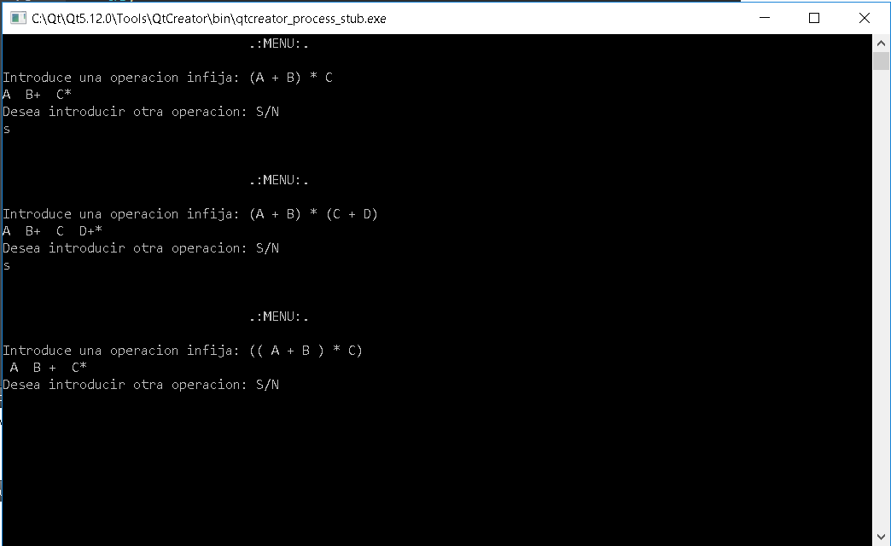

Funciona correctamente :3